Main features:
explainability [show citation references from where the data of reply is gathered],
personalization [consider user preferences and then answer i.e in simple or detailed mode basically],
past history consideration [everytime user gives something new input , important features from it are stores. they are considered everytime while user asks a question to answer. Basic implementation like storing of user's important details like his previous issues etc mentioned at the time of registration, and also from previous chats key points to be stored in database under his user id or something unique that belongs to a user. and later, while generating outputs later for any user asked questions, consider all the data of that user, and answer accordingly.],
data updation of user [ data of user which is stored in database under his unique id, needs to be updated after each chat, if any meaningful information is there in the chat messages],
multi lingual [ effective translation of inputs and outputs to native languages],
voice integration [ give input through voice, bot recognizes the input given by the user dynamically, converts it into text, through python libraries, parses it, generates and processes output],
dashboards [ use of data analytics, in some areas of the chatbot, especially in the admin panel, and admin login],
document upload [ ocr scan for understanding user patient ehr records].

Authentication:
Login : firebase authentication by google. ( free to use -> upto limits)
two methods of login : 1. username and password
2. sign in with google
two types of login for different users:
user login
admin login

Optional features:
- ** Remainders to user to do something related to the healthcare through SMTP protocol.
- ** Pain location selector: a body map will be present, and user sometimes cannot express the pain of exact location, at that time, user can use this option and get the human anatomy graph map, select the region of pain.
- Optional integration of ocr for document scan for her records
- Symptom to meaning translator ( AI converts free text to structured medical theme)
- ** Confidence score of output processed by chatbot
- ** Red flag alert system
- The system includes a basic red-flag detection mechanism that identifies potentially urgent symptoms using predefined medical keywords.
When triggered, the chatbot shifts to a safety-first response mode and advises professional medical consultation.
- Symptom timeline tracker
- ** User explanation modes : simple and detailed
- Session health summary card
- Symptom importance ranking

** Preferred features to implement, with more weightage to implement these rather than the other ones mentioned.

Interface:
Primary landing page : get started, system console
Get started is for user login and system console is for admin login. Names can be changed later
Primary auth page: login/ register
Dual authentication : separete options for user and admin login
An option of forgot password for user login an otp based one through smtp protocol.
Random number 6 digit generated otpis generated through python and sent through mail by smtp protocol for user and the same is stored in database for a couple of minutes. After that, the otp expires.
After user enters the otp, validate it as success or failure.
If otp matches and current time < expiry time -> success else failure
--> Conclusion of authentication:
RBAC + differentiated login
Two options : user login and admin login
When either of it is clicked, it takes to the same login page.
When credentials are entered, system checks role of person based on credentials (RBAC).
If user-> user dashboard if admin-> admin dashboard
User Features:
- A dashboard after login or register
- At the time of registration, ask some questions like name, age, gender etc
- Too many questions regarding their personal data should not be asked
- And also, there must be an option to update the user data, I.e to add/give extra infromation related to the user to chatbot inside the sidebar area.

Admin Features:
- A dashboard after login
- Features:
- User overview:
- - number of users registered
- - active users(last 24h/week)
- Usage analytics:
- - number of chat sessions
- - average questions per session
- - average session duration
- Feature usage analytics:
- - percentage of users using body map selection
- - percentage of users using adaptive questioning
- - percentage of users using simple vs detailed explanations
- System health and monitoring:
- - login success vs failure count
- - performance : average response time
- Feedback summary:
- - summary of all users overall feedback using AI or NLP
- Optional features:
- - user segmentation (age wise, gender wise)
- - model/ logic version info:
- - current logic version
- - last update date

Main chat area:
-- Features: (UI / UX)
- Chatbot name
- Chat refresh button
- Present date
- Chatbot message
- Working status (online or offline)
- Send button
- Message type area
- Emoji selection pane
- Attachments like docs for ocr scan, pictures etc
- Scroll button to go through the chat from top to bottom
-- Additional Features:
- Bot typing indicator:
- Like HygionX is thinking ( while the chatbot is retrieving the data to reply)
- Body map area of difficulty selector
- Voice integration (dynamicallt converts voice/speech to text through py libraries)

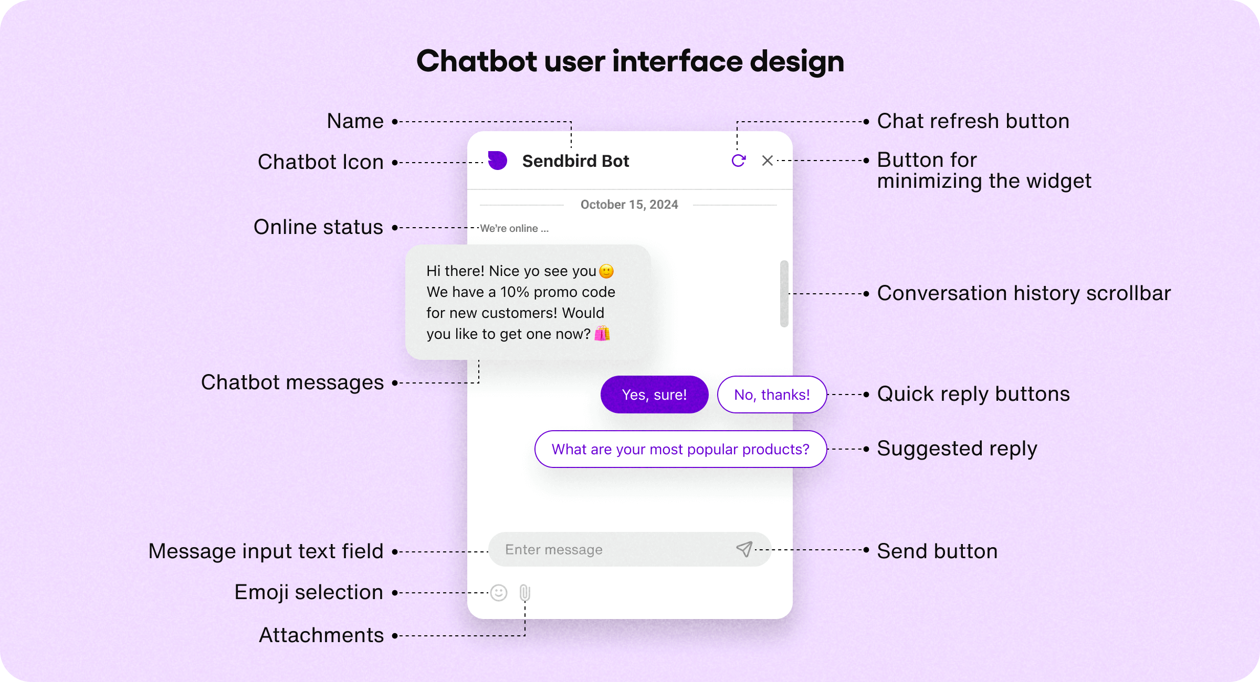

Sidebar:
- Components:
- Home
- takes back to either landing page or other features page
- Health assistant:
- takes to chatbot page
- My sessions:
- keeps a track of user chats and sessions
- Health tips:
- Some pre-trained default health tips related to different context of symptoms and diseases
- Profile:
- Consists of user details like:
- Name, age, gender
- No personal data
- Options to select language
- Health context: * Not mandatory, but can be useful for personalized guidance and replies.
- Consists of some basic questionarrie in box of checkboxes like diabetes, blood pressure, gastritis, pre existing issues etc
- users can select or deselect checkboxes
- finally, a save button to confirm to save the user preferences with user consent.
- and also, a cancel button to revert the changes
- Interaction preferences:
- Simple
- detailed
- language of communication:
- English
- Hindi
- Telugu [ for the current stage, only 3 languages ]
- Privacy and control:
- clear chat history
- clear user saved data [ Erase iser stored data in the Database after consent and double verification of user ]
- Help:
- How to use system:
- Describe symptoms
- Use body map if needed
- Answer follow up questions

- What system does:
- What system does not do:
- no medical diagnosis and treatment
- recheck with doctor
- only for general help and healthcare
- When to seek professional help:
- Highlight key points
- User data privacy:
- Data not shared with anyone
- Version/Project Info

